Конкурс “Young Explorers” – The unusual and amazing places, sculptures and monuments of English-speaking countries” на основе фотографий

1. The Statue of Great Depression bread line, Washington, DC, USA
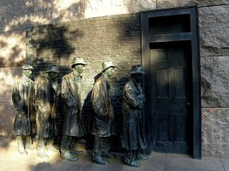

2. The Keeper of the Plains, Wichita, Kansas, USA
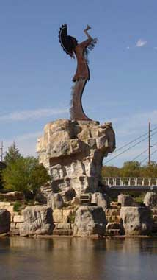

3. World's Largest Basket, Newark, Ohio, USA
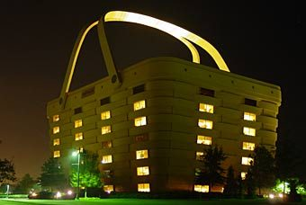

4. Devils Tower, Crook County, Wyoming, USA
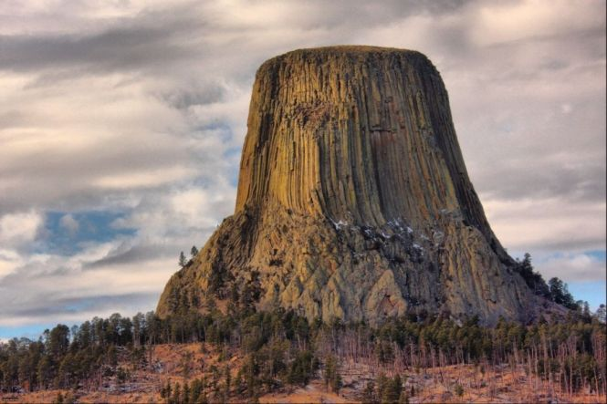

5. Men an Toll, Cornwall, United Kingdom
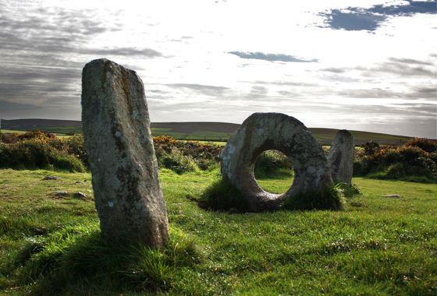

6. Glastonbury Tor, Glastonbury, Somerset, England
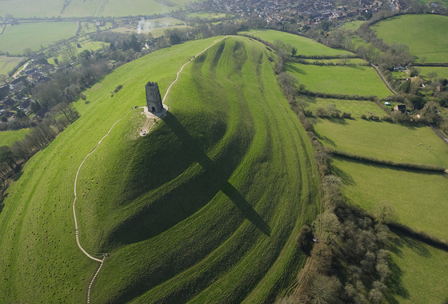

7. The Sculpture «A case history in Hope Street», Liverpool, England
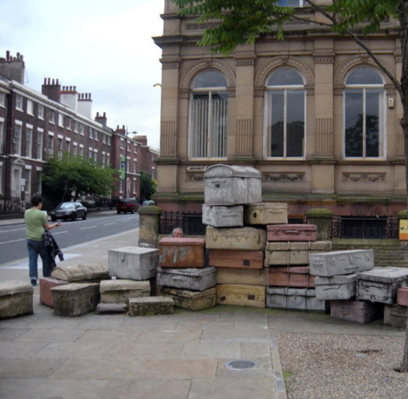

8. Habitat 67, Montreal, Canada
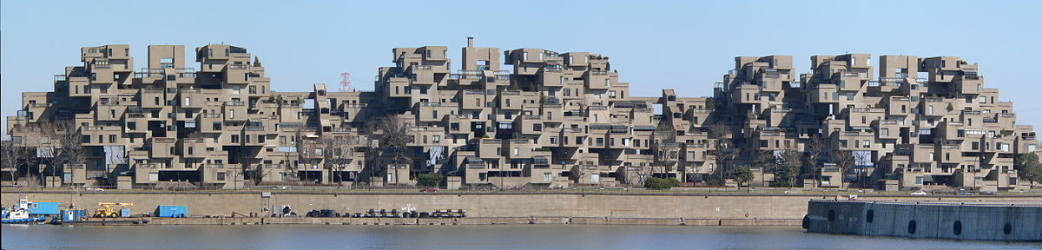

9. The Spotted Lake - (Kliluk), Canada
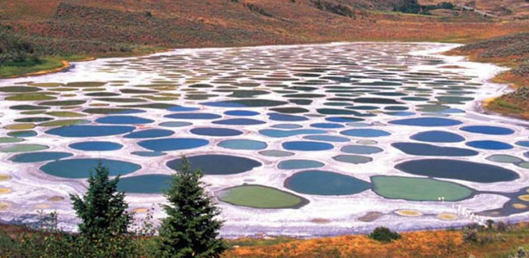

10. The CN Tower, Ontario, Canada
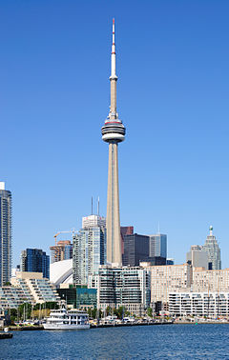

11. The Leaning Tower of Wanaka, New Zealand
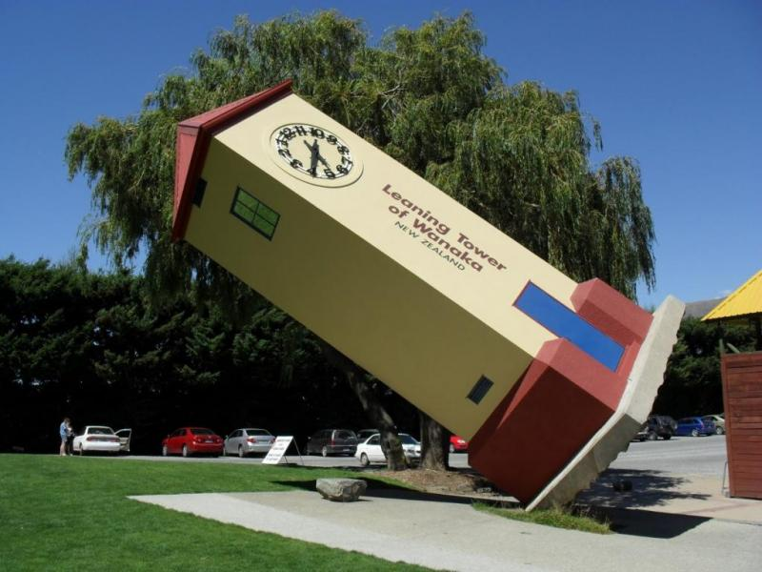

12. The Elephant Rocks, New Zealand
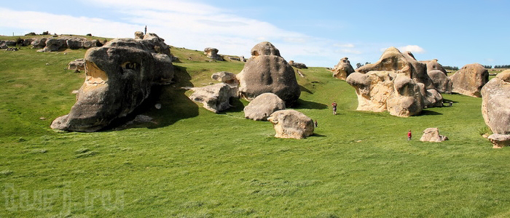

13. The Museum of New Zealand Te Papa Tongarewa
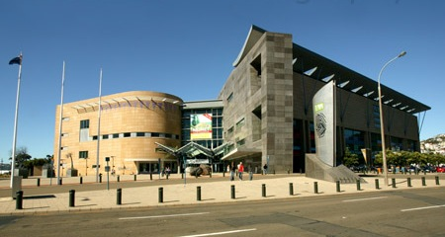

14. Charles La Trobe Statue, Melbourne, Australia
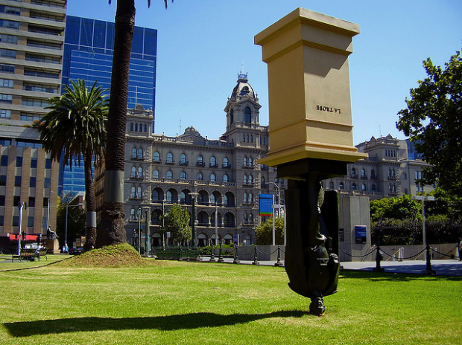

15. The Big Pineapple, Australia
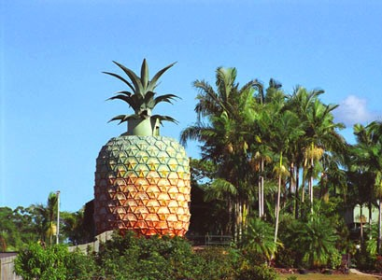

16. The Twelve Apostles, Victoria, Australia.
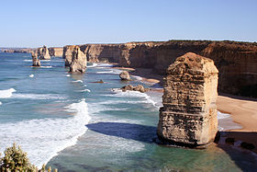

17. The Museum of Australian Currency Notes, Sydney
